Automated Budget Authorization (ABA) Training Document

Table of Contents
Introduction 2
Add a new Automated Budget Authorization Form (ABA) 2
Complete a new Automated Budget Authorization Form (ABA) 5
Add Attachments to ABA Entry 8
Add Additional Lines to the ABA 10
Submit ABA for Approval 11
Add an additional Reviewer or Approver 12
Delete and Recycle ABAs: 14
Add additional new ABA 16
View an existing Automated Budget Authorization Form (ABA) 17
Approve or Deny an ABA 20
Final Approval and Budget Office Handling 21

Introduction

Automated Budget Authorization (also known by ABA)
In EIS, user may request a new ABA, review an already created ABA Request and approve or deny the ABA request. This document outlines the functionalities available to campus users.

Add a new Automated Budget Authorization Form (ABA)

NAVIGATION: Main Menu>Campus Self-Service>Transfers (Budget & IDT)> ABA/IDT Entry
- Login to FSPD at https://myfs.unt.edu/psp/fspd01/?cmd=login.
- Go to Main Menu and select Campus Self-Service.
- Select Transfers (Budget &IDT)
- Next select ABA/IDT Entry to access Electronic ABA details page (The Landing page)

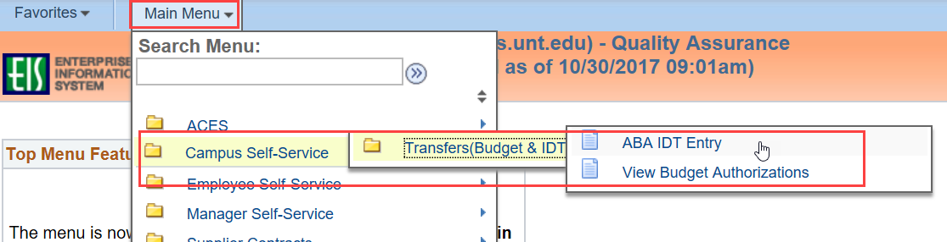

Note: Before accessing a new ABA request form, an ABA details page has been added for campus users, also known as ABA/IDT entry (Landing page). This page is provided to campus users for guidance when trying to complete a new transaction request. (Currently IDT’s are not accessible but will be later.)

- From the ABA/IDT Entry Landing Page, click on the ABA Form button to access ABA Request Form

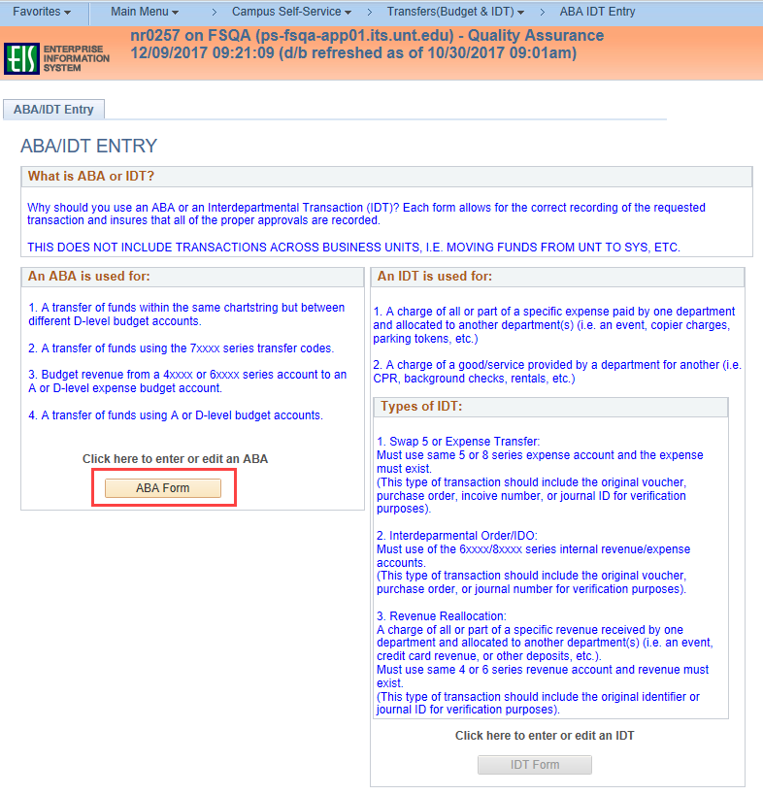

- Select the desired Business Unit and click the Add button.

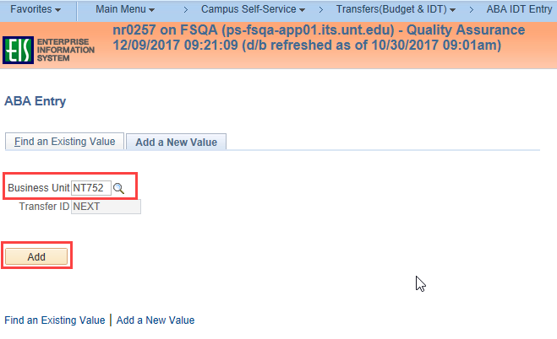

- A blank ABA form will display.

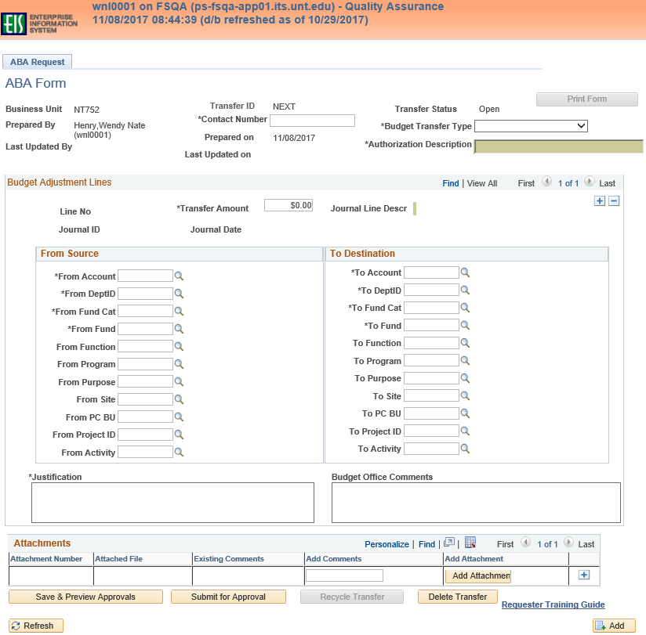

Complete a new Automated Budget Authorization Form (ABA)

Enter all necessary information to complete the ABA form. Required fields are marked with asterisks on the form.

- Contact Number
  - Contact Number field is required. Input your phone number.
- Budget Transfer Type
  - Select either Adjustment or Permanent from drop down
    - Adjustment – Creates a one-time adjustment to a budget.
    - Permanent – Creates a permanent adjustment to a budget.
- Authorization Description
  - Enter the description of the ABA. This description is for all lines of the ABA and allows only 30 characters. This description will be displayed on the Approver box and on the search results page. This description will not be displayed in Cognos.
- Transfer Amount
  - Enter the amount of the transfer. Amount must be entered as #####.##.
- From Source and To Destination
  - Enter chartfield codes for the From Source Chart Strings and To Destination Chart strings. Account, DeptID, Fund Cat, Fund are required. Include all other necessary chartfield values as needed for the transaction.
- Justification
  - Enter a complete justification for the transaction. The Justification box allows up to 254 characters. The first 30 characters of the justification will appear in the Journal Line Description when the ABA has been saved.
  - The Journal Line Descr is displayed at the top of the page.
    - Example, “Covering deficit and expenses for spring event.” will appear on the journal as “20- Covering deficit and expens”. “20” represents the ABA# (Transfer ID#). The Journal Line Descr is displayed at the top of the page and will be displayed in Cognos.
- Budget Office Comments
  - Comments added by the Budget Office at the final approval step will be displayed in this box upon review of the ABA.

- Save & Preview Approvals
  - Once the ABA Form is complete, select the Save & Preview Approvals button to save the form and preview the approval workflow.
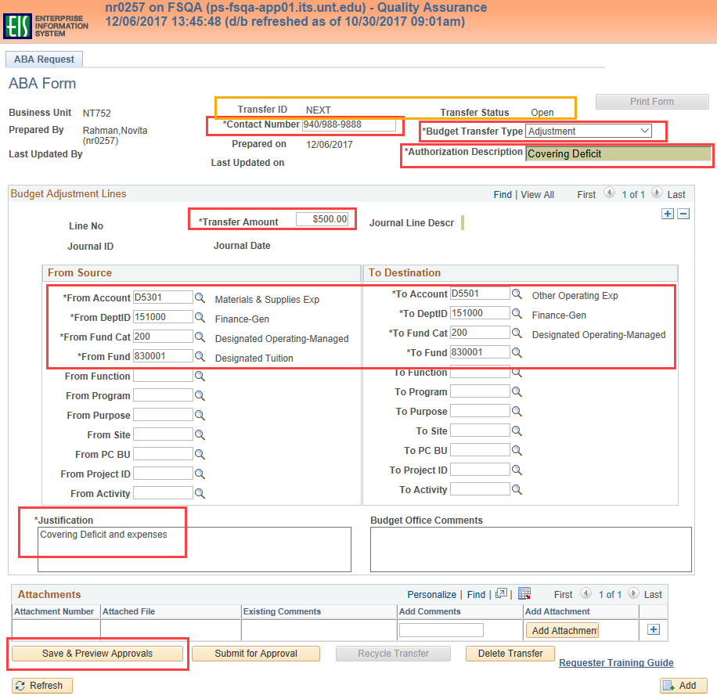

- Budget Request Authorization Approval Page
The approval workflow is displayed once the Save & Preview Approval button is selected. Saving the ABA generates the Transfer ID number, displays the Approval Status as OPEN and gives the requester an opportunity to review the ABA details and approval workflow.

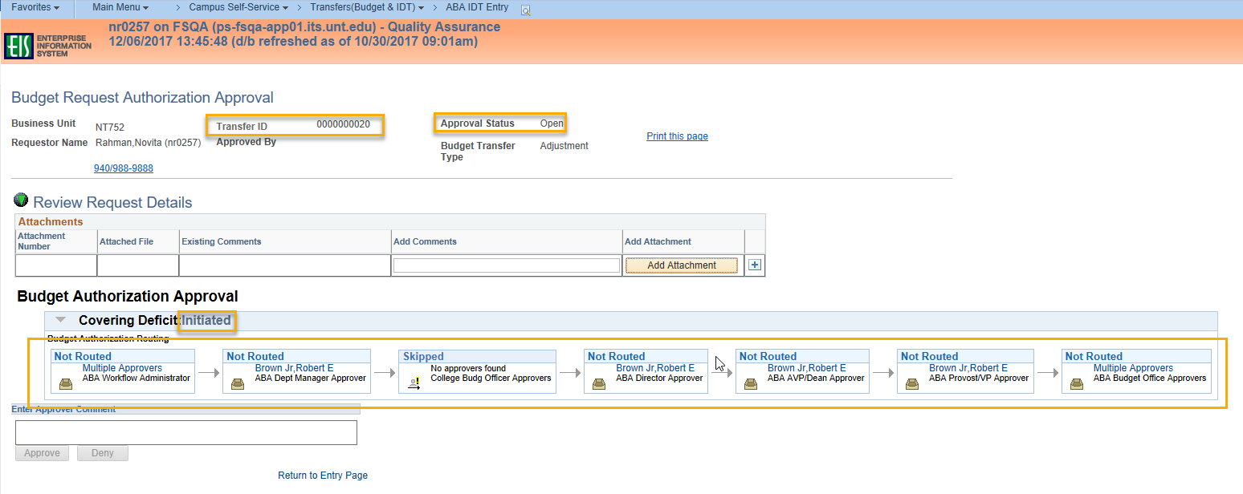
- The Review Request can be expanded to view the ABA details by clicking the green down arrow.
- After the workflow is reviewed, the requester can add an attachment or select Return to Entry Page link to return to ABA Entry Page.
- Additional lines associated with the Authorization Description can be added and/or Submit for Approval can be selected from the ABA entry page.

Add Attachments to ABA Entry

An attachment can be added during the entry of the ABA or after the ABA has been submitted. To add an attachment, select the Add Attachment button. Comments can be added before or after the attachment is added. Browse your computer and Upload the document.
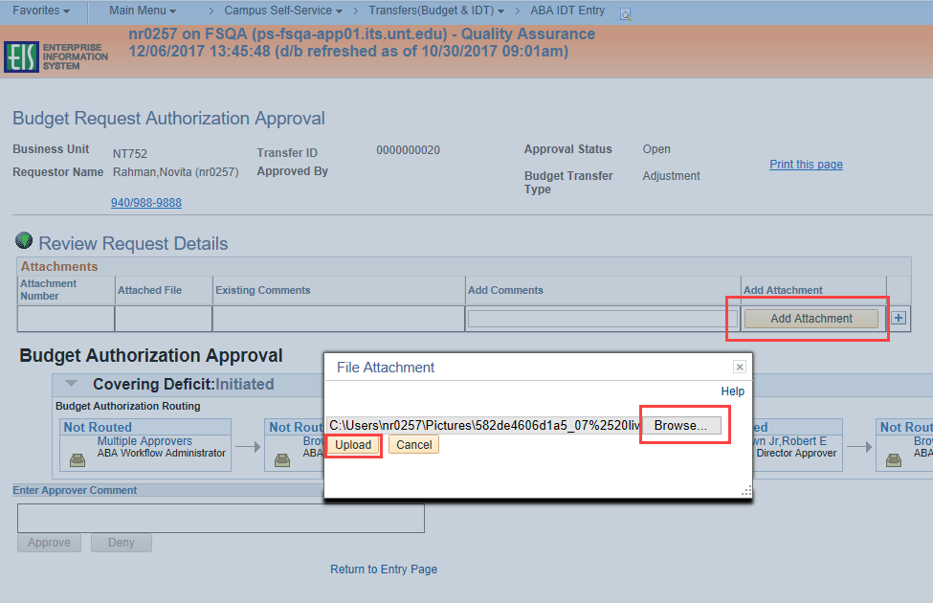

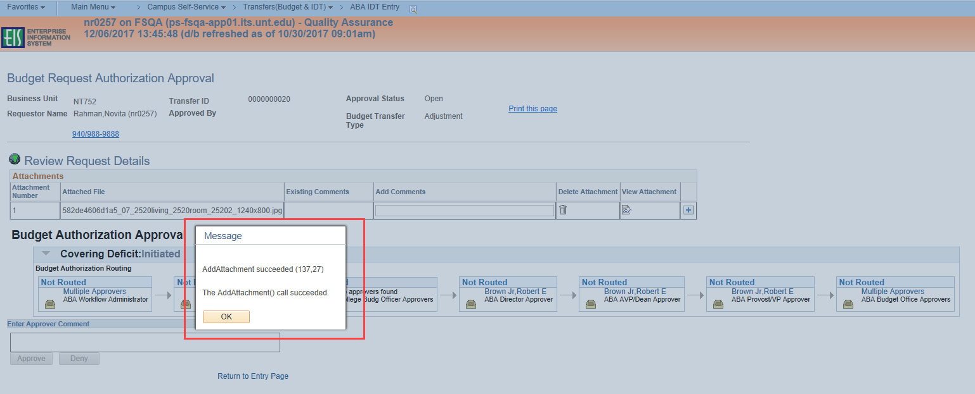
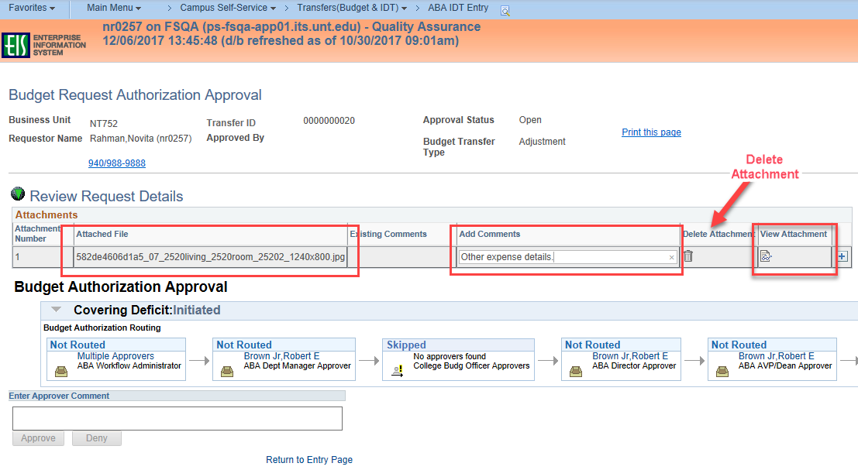
Once the attachment is saved, the attachment can be viewed or deleted, additional comments can be added or another attachment can be added to the ABA Form.
NOTE: Attachments can only be deleted while the ABA is in an Open status and can only be deleted by the individual who added it. Once the ABA enters the approval workflow, attachments cannot be deleted.

Add Additional Lines to the ABA

Additional transaction lines may be added to the ABA, but should be associated with the Authorization Description previously entered. To add lines select the + sign. Keep in mind that the more transactions you add to one ABA, the longer the workflow can potentionally be.

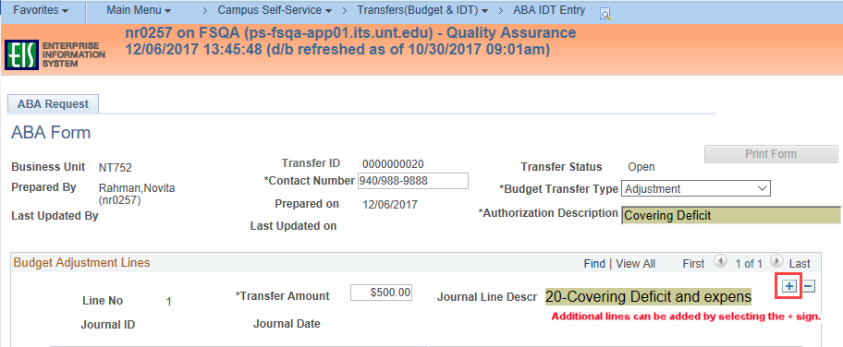

Submit ABA for Approval

The ABA will remain in Open status until it has been submitted for approval. When the ABA is ready to be submitted, select the Submit for Approval button. This is the final step needed to put the ABA into the Approval Workflow.

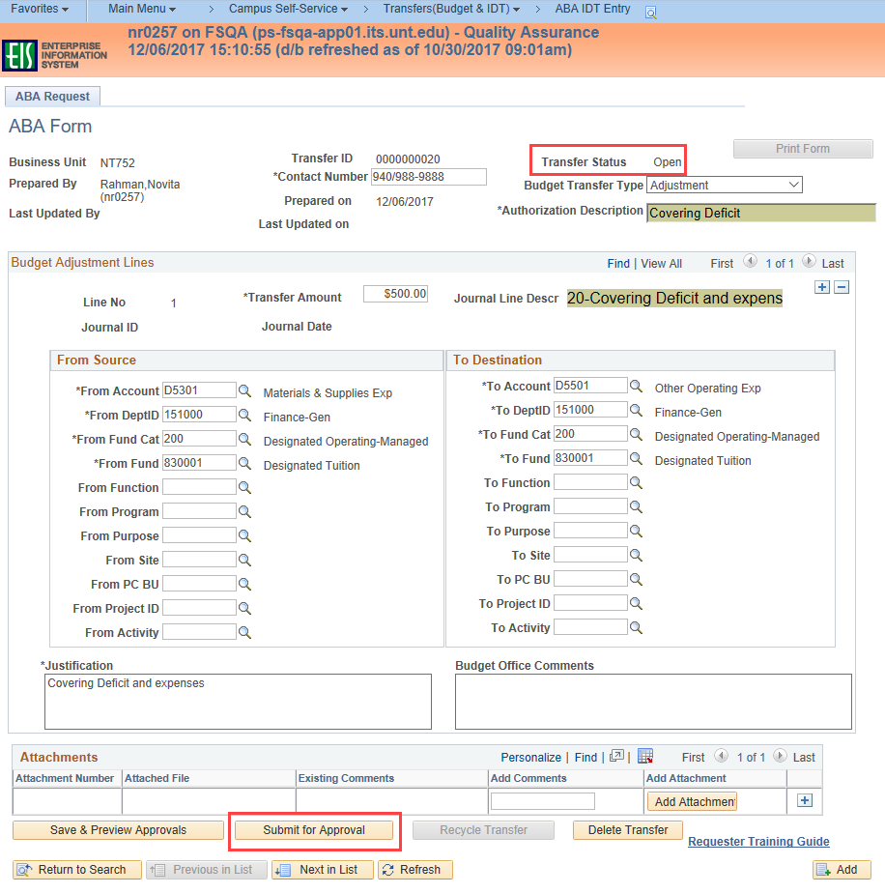

The Budget Request Authorization Approval page is displayed once the ABA has been submitted for approval. The ABA status will change to Pending Approval upon submission. At this point, a reviewer or additional approver may be added by selecting the + sign where the inserted reviewer or approver is needed.

Add an additional Reviewer or Approver

An additional approver or a reviewer can be added once the ABA is submitted for approval but before the Budget Office has approved it. To add an additional approver or a reviewer, select the + sign at the desired location and a pop-up window will ask for additional information. Enter or select the EUID of the individual being added. Select the Approver or Reviewer radio button and then select the Insert button. NOTE: An approver cannot be added after the Budget Office Approvers. The Budget Office will have the final approval and handling.

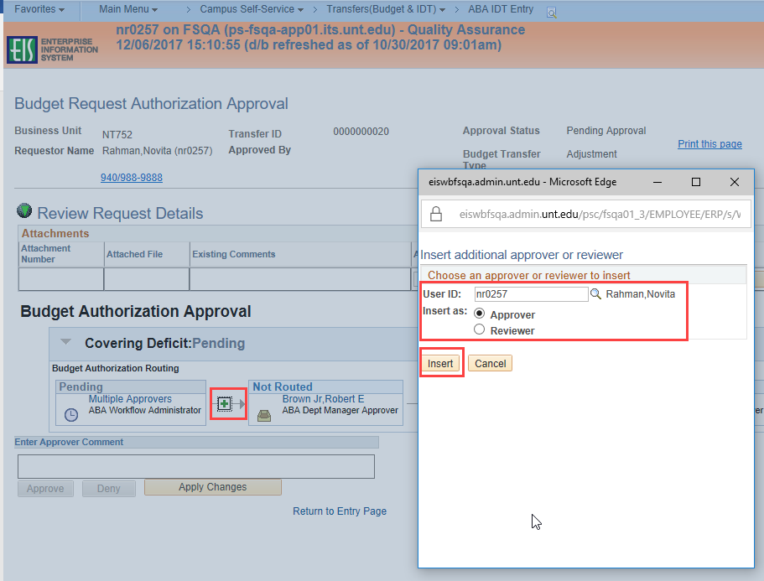
After the reviewer or approver is inserted, the approval workflow with the new approver or reviewer that has been added is displayed. Select the Apply Changes button at the bottom of the screen to save as displayed. Select the Return to Entry Page link to return to the ABA request form.

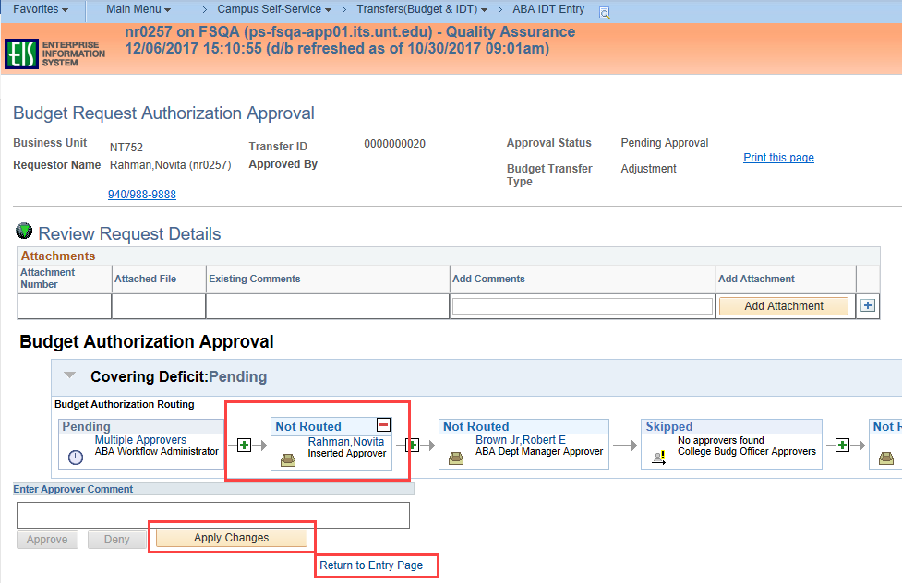

NOTE: The additional approver or reviewer can be deleted by the individual who added them at any time before the added approver/reviewer approves or reviews the ABA. Once the approver/reviewer has approved/reviewed, they cannot be deleted.

Delete and Recycle ABAs:

An ABA request in Open or Pending Approval status may be deleted. An ABA request in Pending Approval status may be recycled. Only the requester of the ABA can perform these functions.

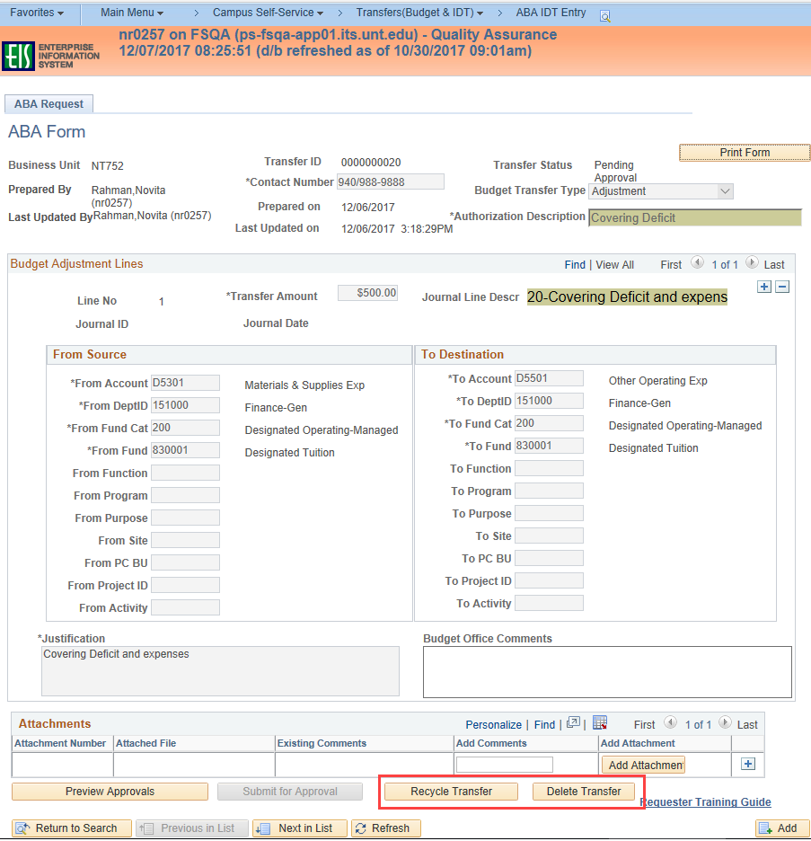

Delete an ABA
Delete Transfer removes the request completely from the system. Requests in an Open or Pending Approval status may be deleted. When attempting to delete an ABA, the following message is displayed. To complete the delete, select the OK button. Once an ABA is deleted, it cannot be retrieved.

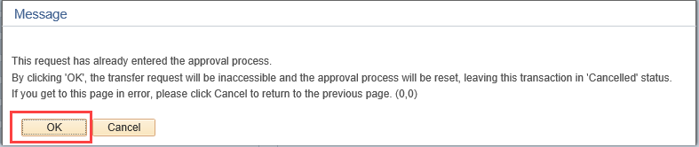

Recycle an ABA
Recycle Transfer puts the request back to Open status and takes it out of the approval workflow. ONLY requests in Pending Approval status can be recycled. If the ABA is in Open status, changes can be made without using the Recycle button.
When attempting to recycle an ABA, the following message is displayed. To complete the recycle, select the OK button. Once the ABA is recycled, it is taken out of the approval workflow and the Budget Adjustment Lines can be modified by the requester.
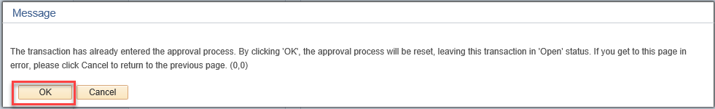

Add additional new ABA

Select the Add button to create new automated budget authorization form.
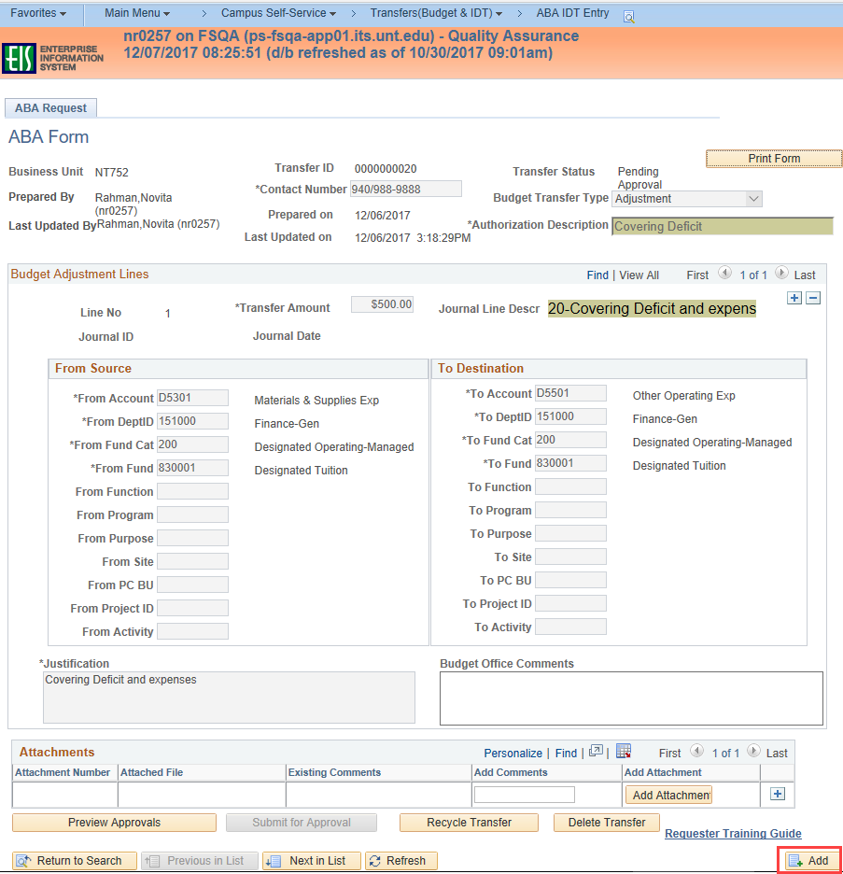

View an existing Automated Budget Authorization Form (ABA)

NAVIGATION: EIS>Campus Self-Service>Transfers (Budget & IDT)>ABA/IDT Entry>ABA form>Find an Existing Value

To view an existing ABA, select Find an Existing Value from the ABA Budget Authorization menu and fill in as many of the fields necessary to narrow the search results. Search results are dependent on the search criteria selected. If nothing is filled in and the Search button is selected, all of the ABAs in the system will be returned. The more fields selected, the narrower the results. Most common searches will be by Transfer ID number, Transfer Status or by User ID.

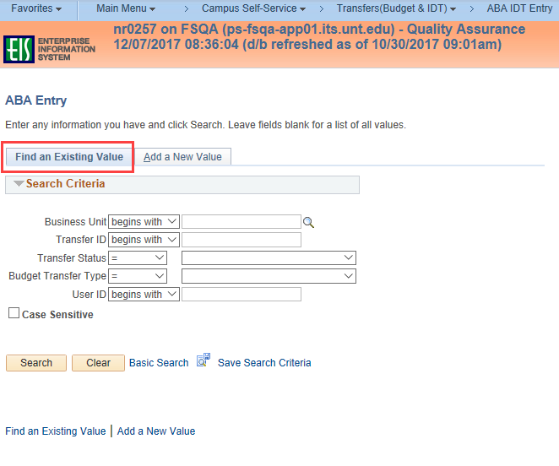
Search criteria defined:
- Business Unit – enter or select the Business Unit of the ABA.
- Transfer ID – enter the Transfer ID number, if known.
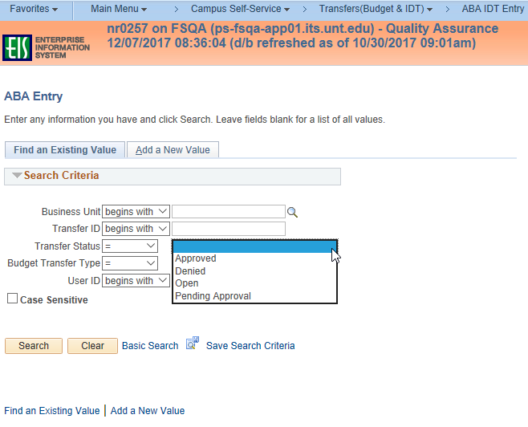
- Transfer Status – select the status type from drop down.
Transfer Status types:
- Approved – ABA has been approved
- Denied – ABA has been denied during the approval workflow
- Open – ABA is open/active and has not been submitted for approval
- Pending Approval – ABA has been submitted for approval but not yet finalized

- Budget Transfer Type – select Budget Transfer type from drop down.
Budget Transfer Types:
- Adjustment – request is for a one-time adjustment to budget
- Permanent – request is for a permanent change to budget

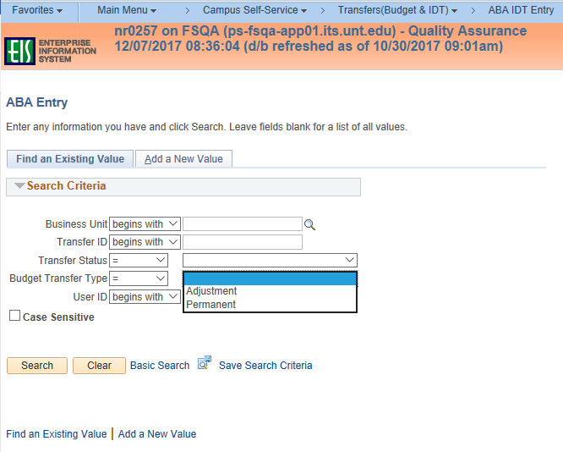

- User ID – enter EUID of individual (requestor) who has entered ABAs in the system

Approve or Deny an ABA

NAVIGATION: EIS>Worklist

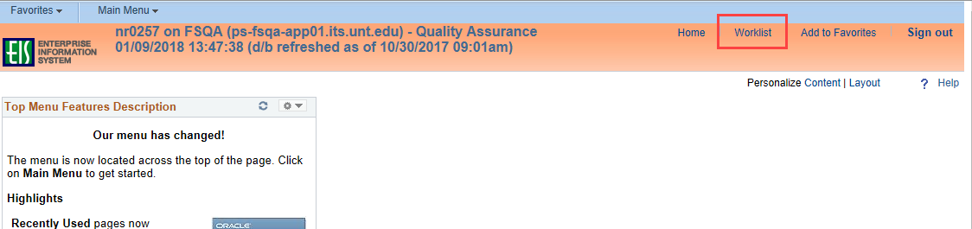

Approvers/Reviewers will receive an email when an ABA is ready to be approved. An ABA can be approved or denied from the worklist of the approver or the reviewer. Select the desired ABA request from the list and click on the link to open the ABA request.
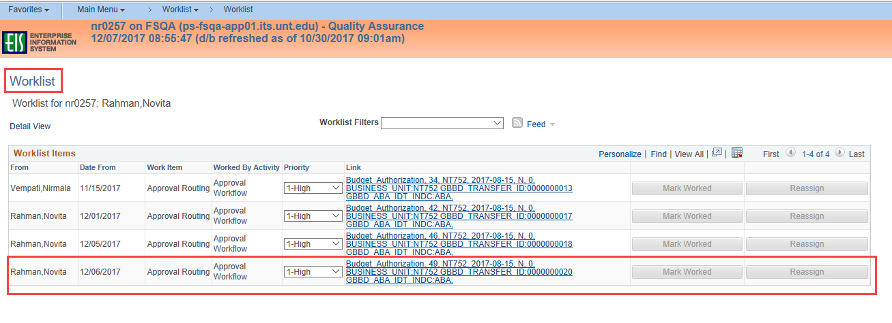
Select the Approve button to approve an ABA. Select the Deny button when the ABA cannot be approved. A comment must be entered in Enter Approver Comment field when the form is denied.
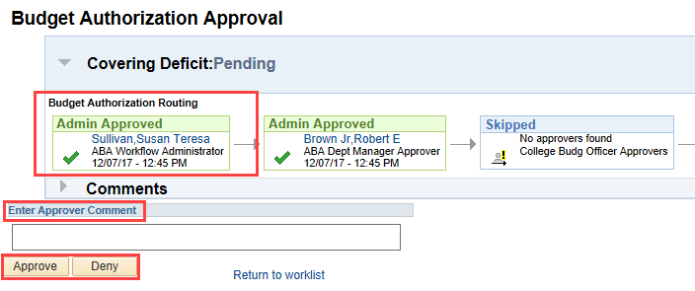

Final Approval and Budget Office Handling

Budget Office can view the approval workflow, complete the Budget Office Use Only box, approve or deny to finalize the ABA request.
The Budget Office Use Only box indicates the handling of the request. The Journal Type, Budget Entry Type, Manual Journal Type (if applicable), Current or Previous Year and Budget Office Approver Comments will be displayed on an ABA request in Approved status.
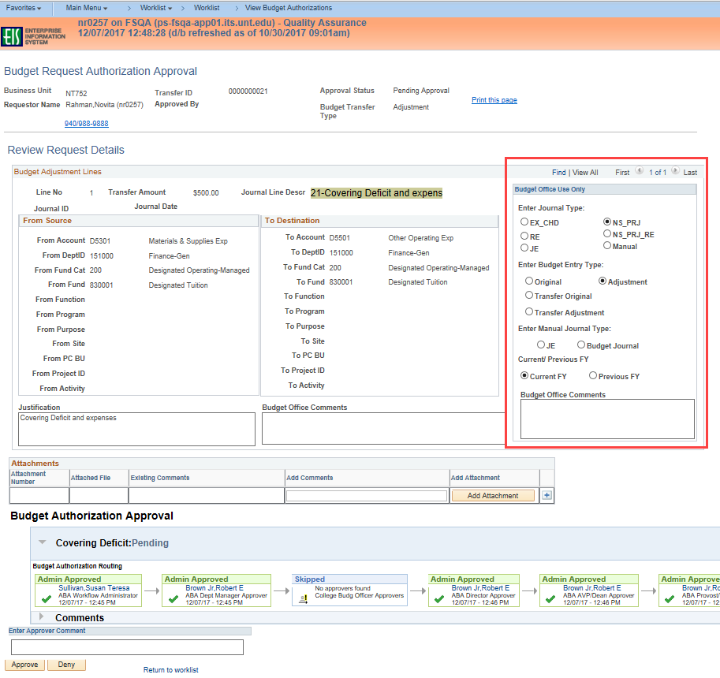

When Budget Office approval is complete, the Transfer Status changes to Approved.
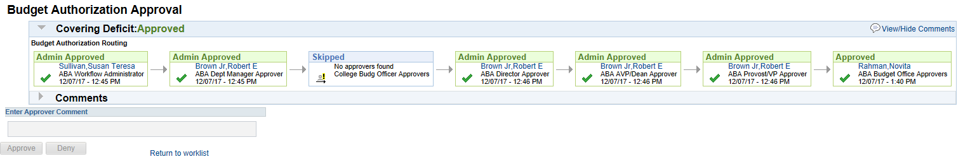
Select the Print Form button to print a copy of the ABA. To view the approval information and any comments, select View Approvals button.
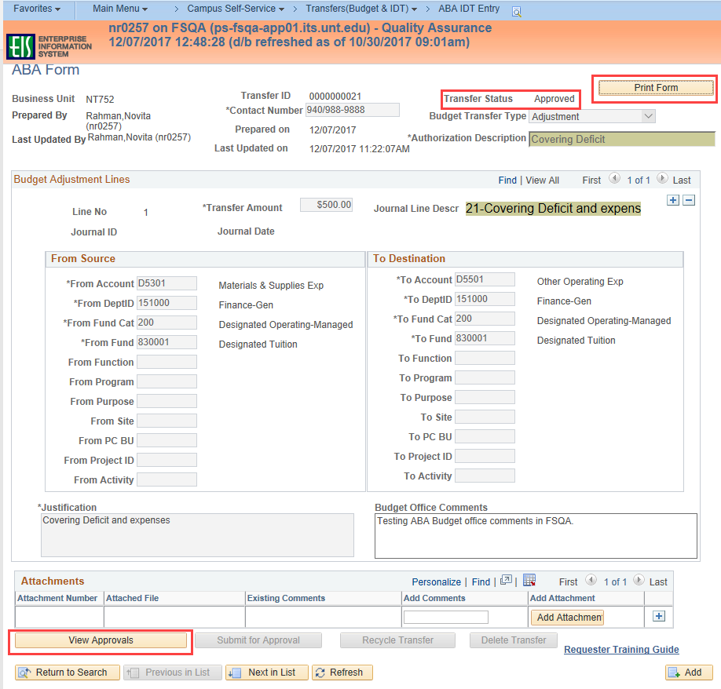
To expand the information, click the gray arrow.
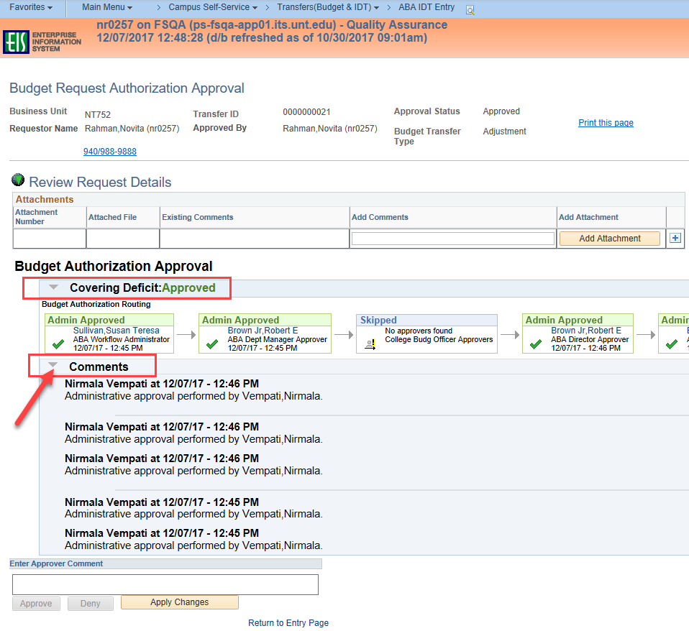

Upon identification of the journal and approval of the ABA by Budget Office, the system will automatically generate the journals for the requests. The journal number and date of the journal will be displayed.
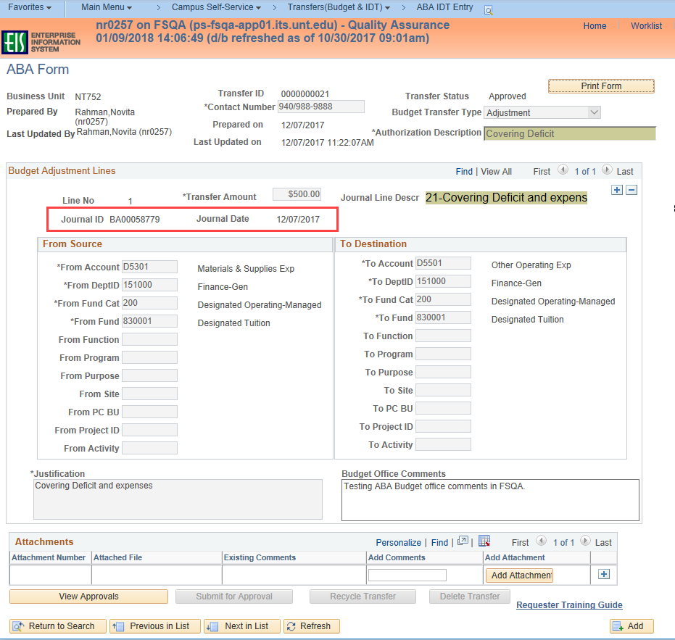

Version History
Date | Version | Revised By | Comments
12/8/17 | DRAFT | Novita Rahman and Wendy Henry
2/2/18 | Final Draft | Novita Rahman
3/2/18 | 1.0 | Brenda Cates and Novita Rahman

