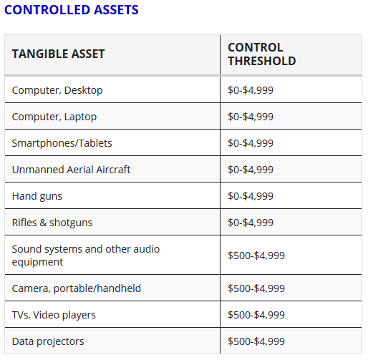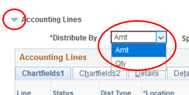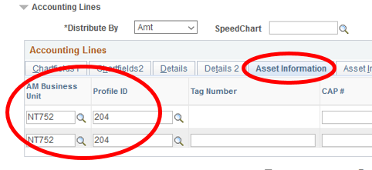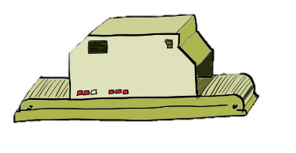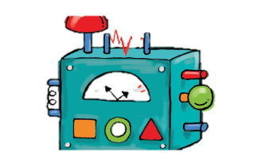

**Not over $5,000.** Warranty and Cleaner Fluid are not set-up costs so Lab Equipment is 334-02, Warranty is 931-46 and the Fluid is 615-02 for supplies

**Common things that need to be tagged and bought on requisitions:**

Email [JosephNavapraditar@unt.edu](mailto:JosephNavapraditar@unt.edu) for questions!

**2**

**1**

1. Distribute By is “AMT”
2. All lines have the same Profile ID (All the same or all blank)

$500 Cleaner Fluid

$600 Warranty

**Is over $5,000.** These are all set-up costs totaling over $5,000 and each of these line items would use the same category code as the Lab Equipment, 334-18

$800 Shipping

$400 Part that only works with Lab Equipment

$4,500 Lab Equipment

$4,000 Lab Equipment

If the Item AND its set-up costs are over $5,000 they would all use the same category code that says “Greater than $5k.”

**Over $5,000 Treatment:** When purchasing anything over $5,000, keep these examples in mind. When saying $5,000 we're looking for the Total Set-Up Costs. Includes Installations and Shipping but not Warranty or extra supplies. This is because we could technically still set up a machine if we didn't buy the warranty or the extra supplies.

Full list here: <https://budget.unt.edu/documents>

Full list here: <https://assetmanagement.unt.edu/asset-classification>

Email [Joseph.Navapraditar@unt.edu](mailto:Joseph.Navapraditar@unt.edu) for any questions!